Repeated Measures ANOVA

| **Within Subjects Effects** | | | | | | | | | | | | | |
| --- | --- | --- | --- | --- | --- | --- | --- | --- | --- | --- | --- | --- | --- |
|  |  |  |  |  |  |  |  |  |  |  |  |  |  |
|  | | **Sum of Squares** | | **df** | | **Mean Square** | | **F** | | **p** | | **partial η²** | |
| Exclusion |  | 0.0420 |  | 1 |  | 0.0420 |  | 2.78 |  | 0.115 |  | 0.148 |  |
| Residual |  | 0.2421 |  | 16 |  | 0.0151 |  |  |  |  |  |  |  |
| Social |  | 20.0562 |  | 1 |  | 20.0562 |  | 92.36 |  | < .001 |  | 0.852 |  |
| Residual |  | 3.4746 |  | 16 |  | 0.2172 |  |  |  |  |  |  |  |
| Exclusion ✻ Social |  | 0.0461 |  | 1 |  | 0.0461 |  | 2.51 |  | 0.133 |  | 0.136 |  |
| Residual |  | 0.2935 |  | 16 |  | 0.0183 |  |  |  |  |  |  |  |
| Note. Type 3 Sums of Squares | | | | | | | | | | | | | |
|  | | | | | | | | | | | | | |

| **Between Subjects Effects** | | | | | | | | | | | | | |
| --- | --- | --- | --- | --- | --- | --- | --- | --- | --- | --- | --- | --- | --- |
|  |  |  |  |  |  |  |  |  |  |  |  |  |  |
|  | | **Sum of Squares** | | **df** | | **Mean Square** | | **F** | | **p** | | **partial η²** | |
| Residual |  | 1.45 |  | 16 |  | 0.0907 |  |  |  |  |  |  |  |
| Note. Type 3 Sums of Squares | | | | | | | | | | | | | |
|  | | | | | | | | | | | | | |

| **Post Hoc Comparisons - Exclusion** | | | | | | | | | | | | | | | |
| --- | --- | --- | --- | --- | --- | --- | --- | --- | --- | --- | --- | --- | --- | --- | --- |
| **Comparison** | | | | | |  | | | | | | | | | |
| **Exclusion** | |  | | **Exclusion** | | **Mean Difference** | | **SE** | | **df** | | **t** | | **ptukey** | |
| Pre |  | - |  | Post |  | 0.0497 |  | 0.0298 |  | 16.0 |  | 1.67 |  | 0.115 |  |
|  | | | | | | | | | | | | | | | |

| **Post Hoc Comparisons - Social** | | | | | | | | | | | | | | | |
| --- | --- | --- | --- | --- | --- | --- | --- | --- | --- | --- | --- | --- | --- | --- | --- |
| **Comparison** | | | | | |  | | | | | | | | | |
| **Social** | |  | | **Social** | | **Mean Difference** | | **SE** | | **df** | | **t** | | **ptukey** | |
| Social |  | - |  | NonSocial |  | 1.09 |  | 0.113 |  | 16.0 |  | 9.61 |  | < .001 |  |
|  | | | | | | | | | | | | | | | |

| **Post Hoc Comparisons - Exclusion ✻ Social** | | | | | | | | | | | | | | | | | | | |
| --- | --- | --- | --- | --- | --- | --- | --- | --- | --- | --- | --- | --- | --- | --- | --- | --- | --- | --- | --- |
| **Comparison** | | | | | | | | | |  | | | | | | | | | |
| **Exclusion** | | **Social** | |  | | **Exclusion** | | **Social** | | **Mean Difference** | | **SE** | | **df** | | **t** | | **ptukey** | |
| Pre |  | Social |  | - |  | Pre |  | NonSocial |  | 1.13824 |  | 0.1177 |  | 18.7 |  | 9.6706 |  | < .001 |  |
|  |  |  |  | - |  | Post |  | Social |  | 0.10176 |  | 0.0444 |  | 31.7 |  | 2.2934 |  | 0.121 |  |
|  |  |  |  | - |  | Post |  | NonSocial |  | 1.13588 |  | 0.1169 |  | 18.2 |  | 9.7172 |  | < .001 |  |
|  |  | NonSocial |  | - |  | Post |  | Social |  | -1.03647 |  | 0.1169 |  | 18.2 |  | -8.8667 |  | < .001 |  |
|  |  |  |  | - |  | Post |  | NonSocial |  | -0.00235 |  | 0.0444 |  | 31.7 |  | -0.0530 |  | 1.000 |  |
| Post |  | Social |  | - |  | Post |  | NonSocial |  | 1.03412 |  | 0.1177 |  | 18.7 |  | 8.7860 |  | < .001 |  |
|  | | | | | | | | | | | | | | | | | | | |

**Estimated Marginal Means**

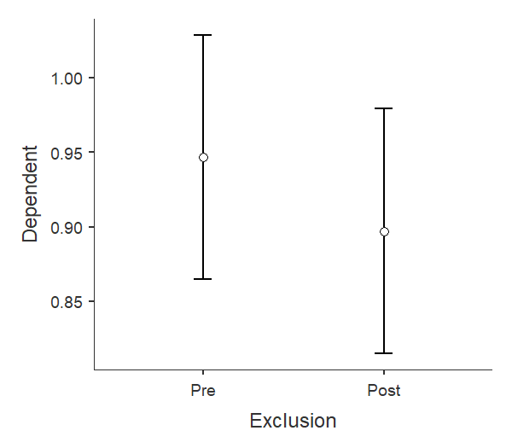

| **Estimated Marginal Means - Exclusion** | | | | | | | | | |
| --- | --- | --- | --- | --- | --- | --- | --- | --- | --- |
|  | | | | | | **95% Confidence Interval** | | | |
| **Exclusion** | | **Mean** | | **SE** | | **Lower** | | **Upper** | |
| Pre |  | 0.947 |  | 0.0394 |  | 0.865 |  | 1.029 |  |
| Post |  | 0.897 |  | 0.0394 |  | 0.815 |  | 0.979 |  |
|  | | | | | | | | | |

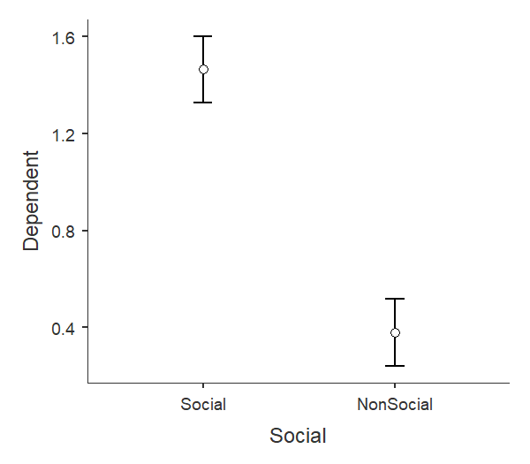

| **Estimated Marginal Means - Social** | | | | | | | | | |
| --- | --- | --- | --- | --- | --- | --- | --- | --- | --- |
|  | | | | | | **95% Confidence Interval** | | | |
| **Social** | | **Mean** | | **SE** | | **Lower** | | **Upper** | |
| Social |  | 1.465 |  | 0.0673 |  | 1.327 |  | 1.603 |  |
| NonSocial |  | 0.379 |  | 0.0673 |  | 0.241 |  | 0.517 |  |
|  | | | | | | | | | |